SIMATS ENGINEERING
ASSESSMENT TOOL 3

COURSE NAME: Artificial Intelligence COURSE CODE: CSA17

COURSE OUTCOME COVERED

CO2: Experiment search and game-solving techniques such as Greedy Search, A*, CSP, Minimax, and Alpha-Beta pruning with heuristic functions for solving complex AI problems efficiently. (BL3)

Assessment Tool Weightage: 40%

Duration: 1 Hour QUESTIONS: 3 Total Marks:30

Annexure A

Dry Run Evaluation

Code of Conduct:

I R S DHANUSRI (192521322) certify that this submission is my original work and that I have adhered to the guidelines specified for this assessment.
I understand that any violation of academic integrity rules will result in disciplinary action.

Signature of the student:

Annexure A

Dry Run Evaluation
1. Question 1 – Breadth-First Search (BFS)
Consider the following graph: A
/ \
B C
/ \ / \
D E F G
Task: Starting from node A, perform a Breadth-First Search (BFS). Complete the following table.
Iteration Queue Visited Node
1
2
3
4
5
6
7
Questions:
- Write the BFS traversal order.
- Show the queue contents after each iteration.
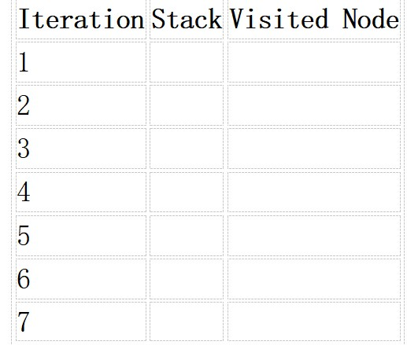
2. Depth-First Search (DFS) Using the same graph,
A
/ \
B C
/ \ / \
D E F G
Perform Depth-First Search (DFS) starting from A.
Complete the table.
3. Initial State :
1 3 6
5 0 2
4 7 8

Goal State :
1 2 3
4 5 6
7 8 0

Task
Trace Breadth-First Search (BFS) until the goal state is reached.
Fill in the table.
Iteration Current State Queue Before Expansion Queue After Expansion
1
2
3
4
5

Questions
- Which node is expanded in each iteration?
- How many states are generated in total?
- Write the complete solution path from the initial state to the goal state.
- Why does BFS always find the shortest solution in an unweighted 8-puzzle problem?

RUBRICS FOR CALCULATION

Criteria | Weightage (%) | Level 4 –  Exemplary (4) | Level 3 –  Proficient (3) | Level 2 –  Developing (2) | Level 1 –  Beginning (1)
Understandi ng of Search Problem | 20 | Clearly understands the search problem, initial state, goal state, and search strategy. | Understands the problem with minor misunderstandin gs. | Demonstrates partial understanding of the search problem. | Shows little or no understanding of the search problem.
Criteria | Weightage (%) | Level 4 –  Exemplary (4) | Level 3 –  Proficient (3) | Level 2 –  Developing (2) | Level 1 –  Beginning (1)
State  Expansion and Dry Run Execution | 30 | Correctly traces every iteration, expands nodes accurately, and maintains the  Queue/Stack/Priority  Queue without errors. | Performs most iterations correctly with  minor mistakes in state expansion or data structure  updates. | Performs only some iterations correctly; several errors in tracing or node expansion. | Unable to correctly perform the dry run or expand states.
Application of Search Algorithm | 20 | Applies the selected algorithm  (BFS/DFS/UCS)  correctly, following all algorithmic rules. | Applies the algorithm correctly with a few procedural errors. | Applies only basic algorithm steps with noticeable mistakes. | Fails to apply the correct search algorithm.
Accuracy of  Solution Path | 20 | Identifies the correct traversal order/solution path and goal state with proper justification. | Solution path is mostly correct with minor errors. | Partially correct solution path; goal may not be reached correctly. | Incorrect or incomplete solution path.
Presentation and Logical Reasoning | 10 | Queue/Stack/Priority Queue updates, state diagrams, and explanations are neat, organized, and logically presented. | Presentation is clear with minor organizational issues. | Limited explanation and organization; reasoning is partially clear. | Poor presentation with unclear or missing reasoning.

Question 1: Breadth-First Search (BFS)
Given graph:
A
/ \
B C
/ \ / \
D E F G
BFS explores nodes level by level, using a queue (FIFO).
BFS dry-run table
Iteration | Queue before processing | Visited node | Queue after processing
1 | A | A | B, C
2 | B, C | B | C, D, E
3 | C, D, E | C | D, E, F, G
4 | D, E, F, G | D | E, F, G
5 | E, F, G | E | F, G
6 | F, G | F | G
7 | G | G | Empty
Answers
- BFS traversal order: A → B → C → D → E → F → G
- Queue contents after each iteration: As shown in the table above.
Question 2: Depth-First Search (DFS)
DFS explores one branch as deeply as possible before backtracking. Assuming left-to-right traversal, the order is:
DFS traversal: A → B → D → E → C → F → G
Iteration | Visited node | Stack (top at right)
1 | A | C, B
2 | B | C, E, D
3 | D | C, E
4 | E | C
5 | C | G, F
6 | F | G
7 | G | Empty
The stack table assumes that the right child is pushed before the left child, so the left child is visited first.
Question 3: 8-Puzzle Using Breadth-First Search (BFS)
Given Initial State
Initial State
1
3
6
5
2
4
7
8
Goal State
1
2
3
4
5
6
7
8
The blank tile is represented by 0. BFS explores all reachable states level by level, using a queue.
i. Node Expanded in Each Iteration
Using the move order Up, Down, Left, Right, the first five expanded states are:
Iteration | Current state (rows separated by /) | Blank-tile move
1 | 136 / 502 / 478 | Start
2 | 136 / 520 / 478 | Right
3 | 106 / 523 / 478 | Up
4 | 136 / 572 / 408 | Down
5 | 136 / 052 / 478 | Left
These are the first five states removed from the queue and expanded, not the complete solution path.
ii. How Many States Are Generated?
The number of states generated depends on the order in which successor moves are explored and whether duplicate states are discarded.
With the move order Up, Down, Left, Right and duplicate-state detection, 500 distinct states are discovered by the time the goal state is reached, counting the initial state. The goal is at depth 8.
iii. Complete Solution Path
The shortest solution requires 8 moves.
Step | Blank-tile move | State
0 | Initial | 136 / 502 / 478
1 | Right | 136 / 520 / 478
2 | Up | 130 / 526 / 478
3 | Left | 103 / 526 / 478
4 | Down | 123 / 506 / 478
5 | Left | 123 / 056 / 478
6 | Down | 123 / 456 / 078
7 | Right | 123 / 456 / 708
8 | Right | 123 / 456 / 780
The final state is the required goal state:
1 2 3
4 5 6
7 8 0
iv. Why Does BFS Always Find the Shortest Solution?
BFS explores states in increasing order of depth. It examines all states one move away before examining states two moves away, and continues in this manner.
Since every legal move in the 8-puzzle has equal cost, the first goal state reached has the minimum number of moves. Therefore, BFS guarantees a shortest solution when duplicate states are handled correctly and the goal is reachable.
Conclusion: BFS finds the shortest solution in 8 moves for the given initial state, although it may consume significant memory because it stores many states in its queue.

